**Mission 1:**

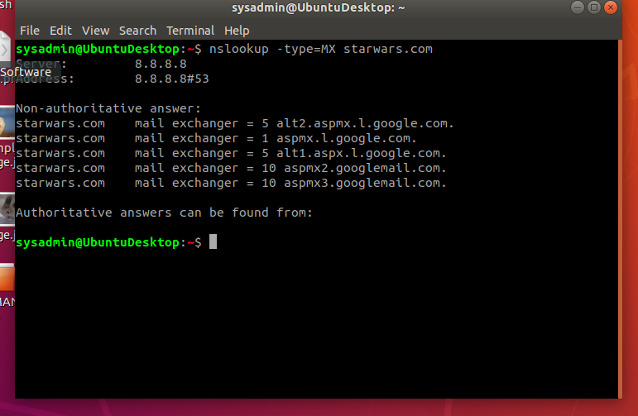

1. According to my findings from nslookup, The Resistance is not receiving emails because their MX records are not being sent to either the primary (asltx.1.google.com) nor to the secondary (asltx.2.google.com) mail servers.
2. Once the DNS Record is corrected, it will look like:

starwars.com mail exchanger = 1 asltx.1.google.com

starwars.com mail exchanger = 5 asltx.2.google.com

**Mission 2:**

1. v=spf1 a mx mx:smtp.secureserver.net include:aspmx.googlemail.com ip4:104.156.250.80 ip4:45.63.15.159 ip4:45.63.4.215

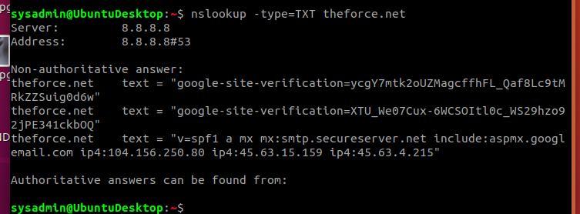

1. The emails are going to spam because The Force failed to update their DNS Text Record after they changed the IP Address of their mail server.
2. Once the DNS Text Record is corrected. it will look like:

theforce.net text = “v=spf1 a mx mx:smtp.secureserver.net include:aspmx.googlemail.com include:45-23-176-21.lightspeed.rcsntx.sbcglobal.net ip4:104.146.250.80 ip4:45.63.15.159 ip4:45.63.4.215

**Mission 3:**

1.

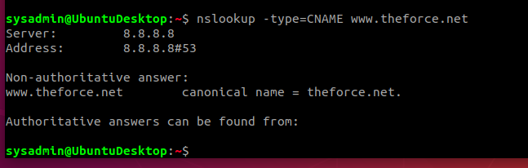

2. When you run the DNS CNAME command, we can see that it is missing the reference from resistance.theforce.net to theforce.net, which is why the subpage of resistance.theforce.net is not redirecting to theforce.net.

3. Once the DNS Record is connected, it will look like:

www.theforce.net canonical name = theforce.net

Resistance.the.force.net canonical name = www.theforce.net

**Mission 4:**

1.

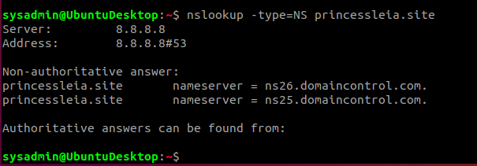

2. In order the fix the DNS Record, we need to add a reference to the backup DNS server so that it reads:

princessleia.site nameserver = ns25.domaincontrol.com.

princessleia.site nameserver = ns2.galaxybackup.com.

**Mission 5:**

1. The shortest path from Batuu to Jedha without going through Planet N is D C E F J I L Q T V

**Mission 6:**

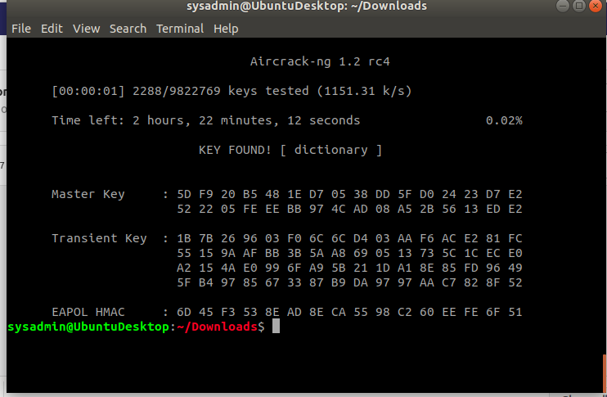

* 1. Host IP Addresses and MAC Addresses by looking at the decrypted ARP traffic.
     1. --------- IP Addresses ------------ MAC Addresses

Target’s 172.16.0.101 is at Cisco-Li_e3:e4:01 (00:13:ce:55:98:ef)

Sender’s 172.16.0.1 is at IntelCor_55:98:ef (00:0f:66:e3:e4:01)

* 1. Document these IP and MAC Addresses, as the resistance will use these IP addresses to launch a retaliatory attack.
     1. --------- IP Addresses ------------ MAC Addresses

Target’s 172.16.0.101 is at Cisco-Li_e3:e4:01 (00:13:ce:55:98:ef)

Sender’s 172.16.0.1 is at IntelCor_55:98:ef (00:0f:66:e3:e4:01)

**Mission 7:**



